 | Pimpri Chinchwad Education Trust’s  Pimpri Chinchwad College of Engineering
Experiment No. 7
Experimentation details
Department: E&TC Academic Year: 2025-26 Semester-I
Class: B.Tech E&TC Course: VLSI Design Lab

Name of Student:
Div and Batch:
Roll No:
Title of the Experiment:
Model and verify FIFO using VHDL and implement on FPGA and evaluate power and timing performance

Software Requirements: Xilinx 14.7 ISE Design Suite
Hardware Requirements: Xilinx Spartan-6 XC6SLX45 FPGA
VHDL Code for FIFO (8x3)

library IEEE;
use IEEE.STD_LOGIC_1164.ALL;
use IEEE.STD_logic_arith.ALL;
use IEEE.STD_logic_unsigned.ALL;
use IEEE.NUMERIC_STD.ALL;

entity fifo is
generic (depth : integer := 8); --depth of fifo
port ( clk : in std_logic;
reset : in std_logic;
enr : in std_logic; --enable read,should be '0' when not in use.
enw : in std_logic; --enable write,should be '0' when not in use.
data_in : in std_logic_vector (2 downto 0); --input data
data_out : out std_logic_vector(2 downto 0); --output data
fifo_empty : out std_logic; --set as '1' when the queue is empty
fifo_full : out std_logic --set as '1' when the queue is full
);
end fifo;

architecture Behavioral of fifo is

type memory_type is array (0 to depth-1) of std_logic_vector(2 downto 0);
signal memory : memory_type :=(others => (others => '0')); --memory for queue.
signal readptr,writeptr : integer := 0; --read and write pointers.
signal empty,full : std_logic := '0';

signal dataout:std_logic_vector(2 downto 0);
begin
fifo_empty <= empty;
fifo_full <= full;

p12:process(clk,reset)
--this is the number of elements stored in fifo at a time.
--this variable is used to decide whether the fifo is empty or full.
variable num_elem : integer := 0;
begin
if(reset = '1') then
dataout <= (others => '0');
empty <= '0';
full <= '0';
readptr <= 0;
writeptr <= 0;
num_elem := 0;
elsif(rising_edge(clk)) then
if(enr = '1' and empty = '0') then --read
dataout <= memory(readptr);
readptr <= readptr + 1;
num_elem := num_elem-1;
end if;
if(enw ='1' and full = '0') then --write
memory(writeptr) <= data_in;
writeptr <= writeptr + 1;
num_elem := num_elem+1;
end if;
--rolling over of the indices.
if(readptr = depth-1) then --resetting read pointer.
readptr <= 0;
end if;
if(writeptr = depth-1) then --resetting write pointer.
writeptr <= 0;
end if;
--setting empty and full flags.
if(num_elem = 0) then
empty <= '1';
else
empty <= '0';
end if;
if(num_elem = depth) then
full <= '1';
else
full <= '0';
end if;
end if;
end process;
data_out<=dataout;

end Behavioral;

RTL Schematic
Block Diagram of Design
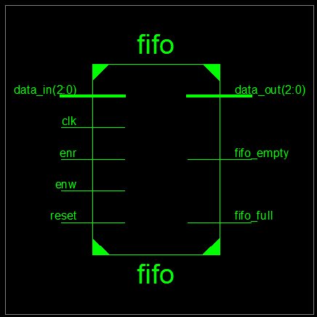

Detailed Schematic
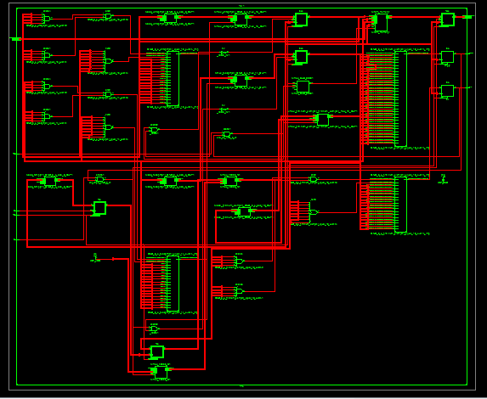
VHDL Test Bench
LIBRARY ieee;
USE ieee.std_logic_1164.ALL;
USE ieee.std_logic_arith.ALL;

ENTITY fifo_tb IS
END fifo_tb;

ARCHITECTURE behavior OF fifo_tb IS
--Inputs and outputs
signal Clk,reset,enr,enw,empty,full : std_logic := '0';
signal data_in,data_out : std_logic_vector(2 downto 0) := (others => '0');
--temporary signals
signal i : integer := 0;
-- Clock period definitions
constant Clk_period : time := 10 ns;
constant depth : integer := 8; --specify depth of fifo here.

BEGIN

-- Instantiate the Unit Under Test (UUT)
uut: entity work.fifo generic map(depth => depth) PORT MAP (clk,reset,enr,enw,data_in,data_out,empty,full);

-- Clock process definitions
Clk_process :process
begin
Clk <= '0';
wait for Clk_period/2;
Clk <= '1';
wait for Clk_period/2;
end process;

-- Stimulus process
stim_proc: process
begin
reset <= '1'; --apply reset for one clock cycle.
wait for clk_period;
reset <= '0';
wait for clk_period*3; --wait for 3 clock periods(simply)
enw <= '1'; enr <= '0'; --write 8 values to fifo.
for i in 1 to depth loop
Data_In <= conv_std_logic_vector(i,3);
wait for clk_period;
end loop;
enw <= '0'; enr <= '1'; --read 8 values from fifo.
wait for clk_period*depth;

wait;
end process;
end behavior;
Simulation Results

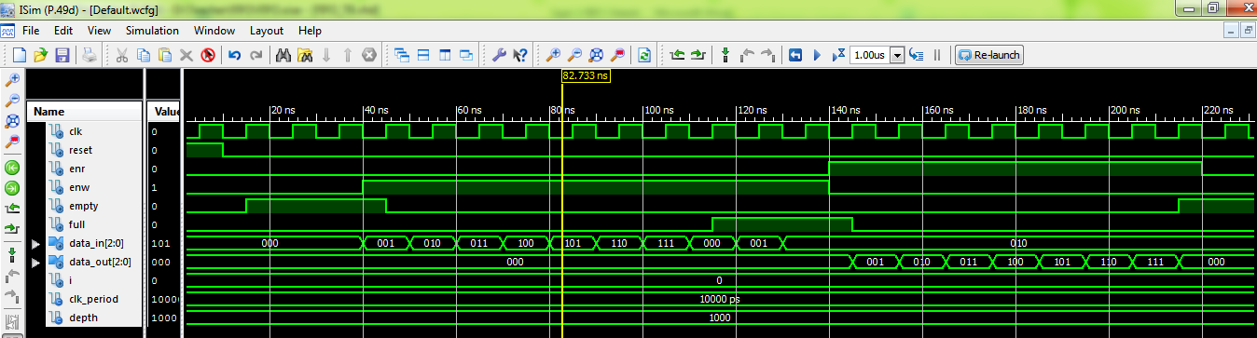

Implementation code with slow clock on Spartan 6
library IEEE;
use IEEE.STD_LOGIC_1164.ALL;
use IEEE.STD_logic_arith.ALL;
use IEEE.STD_logic_unsigned.ALL;
use IEEE.NUMERIC_STD.ALL;

entity fifo is
generic (depth : integer := 8); --depth of fifo
port ( clk : in std_logic;
reset : in std_logic;
enr : in std_logic; --enable read,should be '0' when not in use.
enw : in std_logic; --enable write,should be '0' when not in use.
data_in : in std_logic_vector (2 downto 0); --input data
data_out : out std_logic_vector(2 downto 0); --output data
fifo_empty : out std_logic; --set as '1' when the queue is empty
fifo_full : out std_logic --set as '1' when the queue is full
);
end fifo;

architecture Behavioral of fifo is

type memory_type is array (0 to depth-1) of std_logic_vector(2 downto 0);
signal memory : memory_type :=(others => (others => '0')); --memory for queue.
signal readptr,writeptr : integer := 0; --read and write pointers.
signal empty,full : std_logic := '0';

signal temp:std_logic_vector(27 downto 0);
signal sclk:std_logic;
signal dataout:std_logic_vector(2 downto 0)
begin
fifo_empty <= empty;
fifo_full <= full;
p11: process(clk,reset)
begin
if(reset='1')then temp<=(others=>'0');
elsif(clk'event and clk='1') then
temp<= temp + 1;
end if;
end process;
sclk<=temp(27);
p12:process(sclk,reset)
--this is the number of elements stored in fifo at a time.
--this variable is used to decide whether the fifo is empty or full.
variable num_elem : integer := 0;
begin
if(reset = '1') then
dataout <= (others => '0');
empty <= '0';
full <= '0';
readptr <= 0;
writeptr <= 0;
num_elem := 0;
elsif(rising_edge(sclk)) then
if(enr = '1' and empty = '0') then --read
dataout <= memory(readptr);
readptr <= readptr + 1;
num_elem := num_elem-1;
end if;
if(enw ='1' and full = '0') then --write
memory(writeptr) <= data_in;
writeptr <= writeptr + 1;
num_elem := num_elem+1;
end if;
--rolling over of the indices.
if(readptr = depth-1) then --resetting read pointer.
readptr <= 0;
end if;
if(writeptr = depth-1) then --resetting write pointer.
writeptr <= 0;
end if;
--setting empty and full flags.
if(num_elem = 0) then
empty <= '1';
else
empty <= '0';
end if;
if(num_elem = depth) then
full <= '1';
else
full <= '0';
end if;
end if;
end process;
data_out<=dataout;

end Behavioral;

Device Specifications to be selected while implementing:
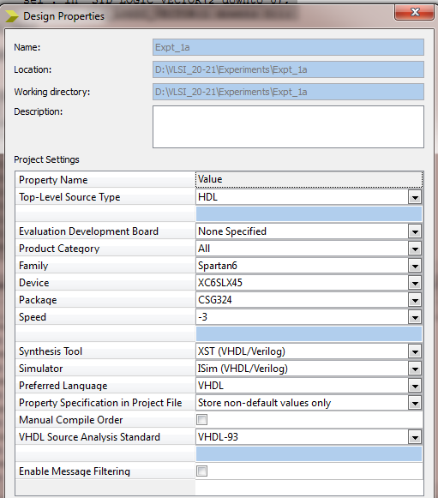
Implementation Constraint File
NET "reset" LOC = "E4";
NET "CLK" LOC ="L15";
NET "enr" LOC ="T5";
NET "enw" LOC ="R5";
NET "data_in<0>" LOC ="A10";
NET "data_in<1>" LOC ="D14";
NET "data_in<2>" LOC ="C14";

NET "data_out<0>" LOC = "U18"; # Bank = 1, Pin name = IO_L52N_M1DQ15, Sch name = LD0
NET "data_out<1>" LOC = "M14"; # Bank = 1, Pin name = IO_L53P, Sch name = LD1
NET "data_out<2>" LOC = "N14"; # Bank = 1, Pin name = IO_L53N_VREF, Sch name = LD2

NET "fifo_empty" LOC = "P16"; # Bank = 1, Pin name = IO_L61P, Sch name = LD3
NET "fifo_full" LOC = "D4";
Implementation Successful
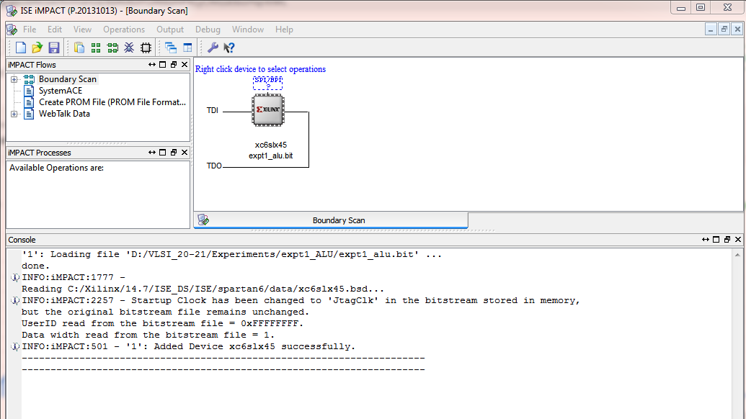
Hardware Snapshots
Digilent ATLYS Spartan 6 FPGA Board
